Cash Transaction Reporting System (CTR)

Date | Author | Comments
18-August-2013 | Md.Fahad Khan | Created

INTRODUCTION
Chapter
1

Citi Transaction Reporting System

CTR stands for Citi transaction report system. CTR is a reporting system for reporting to the Bangladesh bank. It keeps all the relevant account transaction information. This system is based on windows authentication system and allows Maker Checker concept. A user who is a maker he/she cannot authorize that data.

System Details

A user of a system is a person who interacts with the system, to enable its operation, or to utilize its function. There is one or more system user for a specific system.

The System menu contains the following options:

- Department
- Users
- Functional Group
- Assign Functional Group to User
- System Report
- EERS Feed Report

Department: User department name.

User: users who Access the System.

Functional Group: user specific access permission.

Assign Functional Group to user: assigning user to one or more role.

Report: system report and to show all user role.

EERS feed Report: generates files for EERS.

Each of the main items has the submenu items. Name of all menu items and their functionalities are briefly given below:

Menu Name | Functionality
System | Has Submenu
Department | Has Submenu
Detail | Calls User Department Detail Form
Summary | Calls User Department Summary Form
User | Has Submenu
Detail | Calls User Detail Form
Summary | Calls User Department Summary Form
Functional Group | Has Submenu
Detail | Calls User Functional Group Detail Form
Summary | Calls User Functional Group Summary Form
Assign FG to User | Has Submenu
Detail | Calls Assign FG to User Detail Form
Summary | Calls Assign FG to User Summary Form
Report | Has Submenu
System Log | Calls System Log Report
User Role | Calls User Role Report
EERS Feed Report | Calls EERS Feed Report

System Form Details
Chapter
2

User Department Details
Title: Create User Department
Main scenario: It manipulates the user Department. Using this form user can authorize and create User Department. Also the user can update and delete the department under some precondition. Every operation must be authorized. Authorization can be done only authorized power users.
Steps:
Save
- Press Unlock button.
- Then Press New Button.
- Enter all other required field as needed.
- And Press the save button.

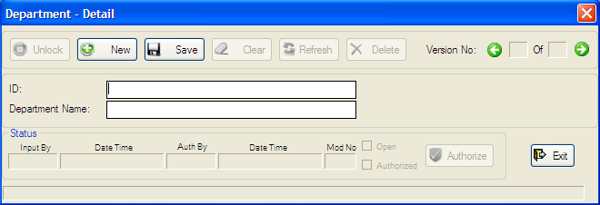

Figure 2.1: Department Details

User Department Summary
Title: User Department Summary
Main scenario: It manipulates the user Department. Using this form user can authorize single or multiple data at once. It also uses to update and delete the department under some precondition. Every operation must be authorized. Authorization can be done only authorized power users.
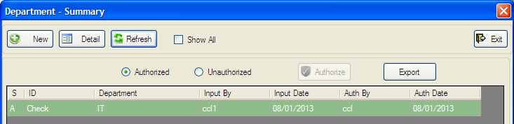
Figure 2.2: Department Summary

Steps:
Authorize (All)
- First click the unauthorized button.
- Click all checkbox.
- Then Click Authorize Button.

Authorize (Single)
- First click the unauthorized button.
- Click The grid which data want to Authorize
- Screen 2.1 Will Appear.
- Click Unlock Button.
- Then Click Authorized Button

Update
- First click to Grid Which Data Want Update.
- Screen 2.1 Will Appear.
- Click Unlock Button.
- Make needed update.
- Press Save Button.
- Update Only Done after Authorized
Delete
- First click to Grid Which Data Want Delete.
- Screen 2.1 Will Appear.
- Click Unlock Button
- Then Press Delete Button.
- Delete Only Done after Authorized.
Export

1. Click Export Button to Export All Department

User Details
Title: Create User
Main scenario: It manipulates the users. Using this form user can authorize and Create new Users. Also user can update and delete the Users under some precondition. Every operation must be authorized. Authorization can be done only authorized power users.

Steps:
Save
- Press Unlock button.
- Then Press New Button.
- Select Department & Status
- Enter all other required field as needed.
- And Press the save button.

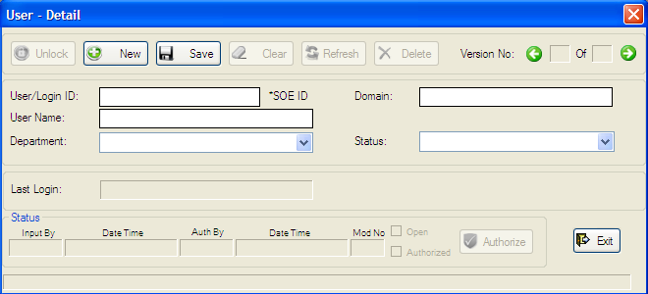

Figure 2.3: User Details

Users Summary
Title: Users Summary
Main scenario: It manipulates the users. Using this form user can authorize single or multiple data at once. Also user can update and delete the users under some precondition. Every operation must be authorized. Authorization can be done only authorized power users.

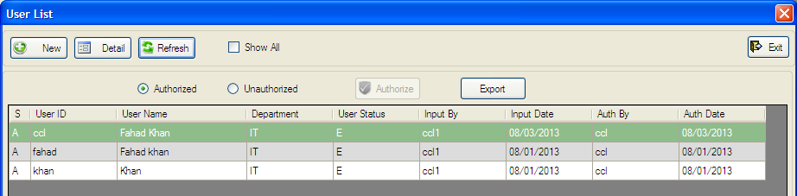
Figure 2.4: Users Summary

Steps:
Authorize (All)
- First click the unauthorized button.
- Click all checkbox.
- Then Click Authorize Button.

Authorize (Single)
- First click the unauthorized button.
- Click The grid which data want to Authorize
- Screen 2.3 will appear.
- Click Unlock Button.
- Then Click Authorized Button

Update
- First click to Grid which data want Update.
- Screen 2.3 Will Appear.
- Click Unlock Button.
- Make needed update.
- Press Save Button.
- Update Only Done after Authorized
Delete
- First click to Grid which data want Delete.
- Screen 2.3 will appear.
- Click Unlock button
- Then press Delete button.
- Delete only done after Authorized.

Export

1. Click Export Button to Export All Users

Functional Group Details
Title: Create User Functional Group
Main scenario: It manipulates the user Functional Groups. Using this form user can create, authorize, update and delete the users Functional Group Permission under some precondition. Every operation must be authorized. Authorization can be done only authorized power users.

Steps:
Save
- Press Unlock button.
- Then Press New Button.
- Enter Functional Group code & description.
- Select department from Dropdown list.
- Click Checkboxes to Form permission from Form Tab
- Click Checkboxes to Menu permission From Menu Tab
- And Press the save button.

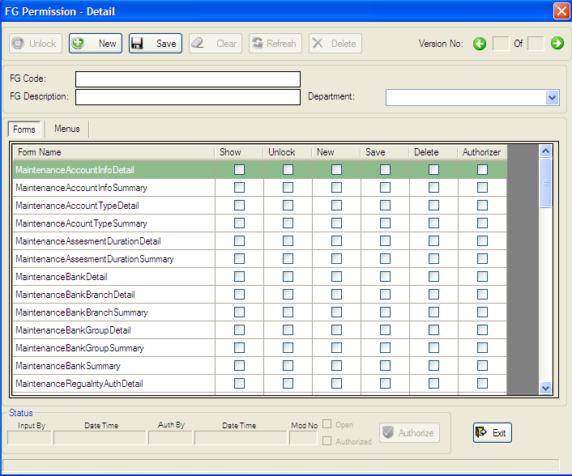

Figure 2.5: User Functional Group Details

Functional Group Summary
Title: User Functional Group Summary
Main scenario: It manipulates the Functional Group. Using this form user can authorize single or multiple data at once. Also user can update and delete the Functional Group under some precondition. Every operation must be authorized. Authorization can be done only authorized power users.
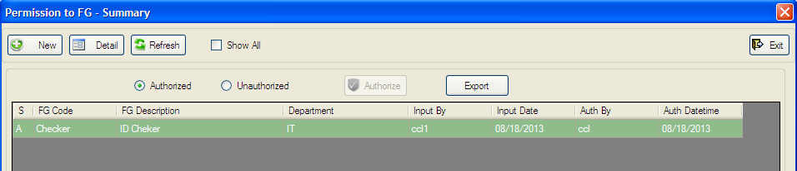
Figure 2.6: Functional Group Summary

Steps:
Authorize (All)
- First click the unauthorized button.
- Click all checkbox.
- Then Click Authorize Button.

Authorize (Single)
- First click the unauthorized button.
- Click The grid which data want to Authorize
- Screen 2.5 will appear.
- Click Unlock Button.
- Then Click Authorized Button

Update
- First click to Grid which data want Update.
- Screen 2.5 Will Appear.
- Click Unlock Button.
- Make needed update.
- Press Save Button.
- Update Only Done after Authorized
Delete
- First click to Grid which data want Delete.
- Screen 2.5 will appear.
- Click Unlock button
- Then press Delete button.
- Delete only done after Authorized.

Export

- Click Export Button to Export All Users

Assign Functional Group to User Details
Title: Assign Functional Group to Users
Main scenario: It manipulates the Functional Group to Assign User. Using this form user can Assign User Role To users. Also the user can authorize, update and delete the Assigning Role under some precondition. Every operation must be authorized. Authorization can be done only authorized power users.

Steps:
Save
- Press Unlock button.
- Then Press New Button.
- Enter User ID.
- Then Shows Available Functional Group.
- Select Require Functional Group By Clicking Arrow.
- And Press the save button.

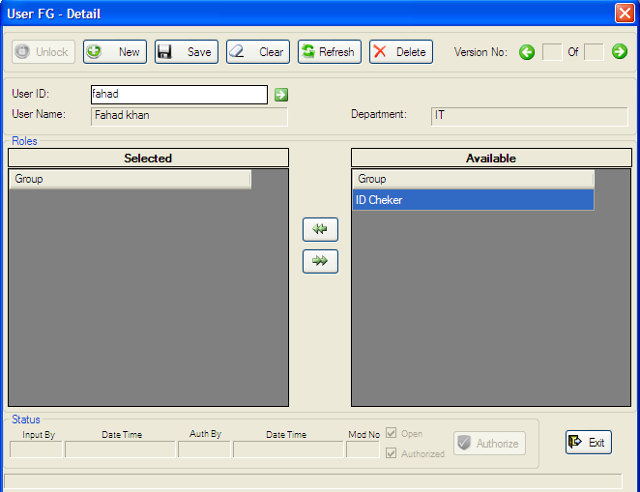

Figure 2.7: User Functional Group Details

Assign Functional Group to User Summary

Title: User Functional Group Summary
Main scenario: It manipulates the Functional Group Assigning to Users. Using this form user can authorize, update and delete the Assigning Functional Group to User under some precondition. Every operation must be authorized. Authorization can be done only authorized power users.

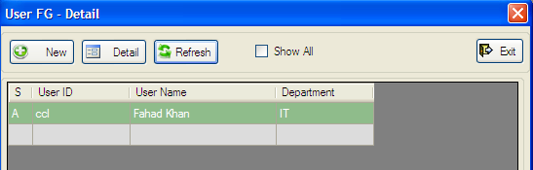
Figure 2.8: Assign Functional Group to users Summary

Steps:

Authorize
- Click The grid which data want to Authorize
- Screen 2.7 will appear.
- Click Unlock Button.
- Then Click Authorized Button

Update
- First click to Grid which data want Update.
- Screen 2.7 Will Appear.
- Click Unlock Button.
- Make needed update.
- Press Save Button.
- Update Only Done after Authorized
Delete
- First click to Grid which data want Delete.
- Screen 2.7 will appear.
- Click Unlock button
- Then press Delete button.
- Delete only done after Authorized.

Reports Details
Chapter
3

System Log Report
Report Title: Log Report
Main scenario: It shows System log report. Using this form user can show log Report by entering any input combination.
Steps:
Parameter
- Enter date Range To show Report
- Enter user id to Show Report.
- Enter phase name to show Report.
- Or Enter Any Combination to Show Report.
- Press Generate Report to show report

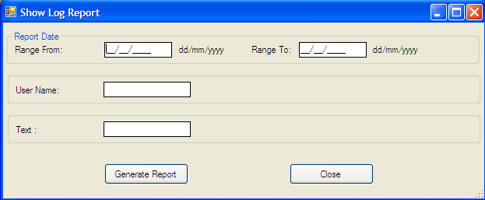

Figure 2.9: System log Report parameter form

Report Output:

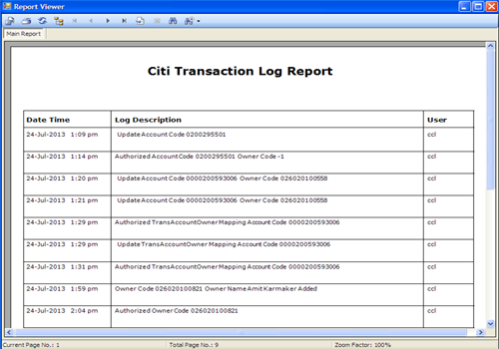
Figure 2.10: System log Report

User Role
Report Title: User Role
Main scenario: It shows User Roles report. Using this report user can see all running user and their status.
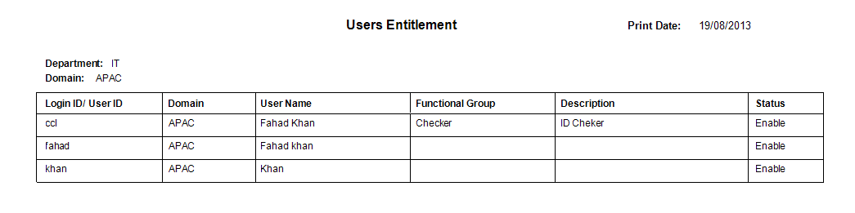
Figure 2.11: user status report

EERS Feed Report
Report Title: EERS Feed Report
Main scenario: It shows EERS Feed report. Using this report user can generate EERS Feed file.

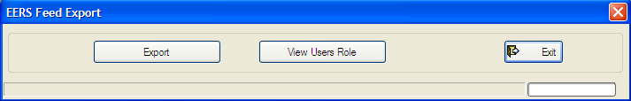
Figure 2.11: EERS Feed report

Conclusion
Chapter
4

For more details please contact service provider.

